EXPERIMENT-13

AIM: Study about Wireshark

Wireshark is an open-source packet analyzer, which is used for education, analysis, software development, communication protocol development, and network troubleshooting.

It is used to track the packets so that each one is filtered to meet our specific needs. It is commonly called as a sniffer, network protocol analyzer, and network analyzer. It is also used by network security engineers to examine security problems.

Wireshark is a free to use application which is used to apprehend the data back and forth. It is often called as a free packet sniffer computer application. It puts the network card into an unselective mode, i.e., to accept all the packets which it receives.

A packet is a unit of data which is transmitted over a network between the origin and the destination. Network packets are small, i.e., maximum 1.5 Kilobytes for Ethernet packets and 64 Kilobytes for IP packets. The data packets in the Wireshark can be viewed online and can be analyzed offline
Installation of Wireshark Software

Below are the steps to install the Wireshark software on the computer:

- Open the web browser.
- Search for 'Download Wireshark.'
- Select the Windows installer according to your system configuration, either 32-bt or 64-bit. Save the program and close the browser.
- Now, open the software, and follow the install instruction by accepting the license.
- The Wireshark is ready for use.
On the network and Internet settings option, we can check the interface connected to our computer.

If you are Linux users, then you will find Wireshark in its package repositories.

Packet Capture Using Wire shark
Capturing your traffic with Wireshark After starting Wireshark, do the following:
  - Select Capture | Interfaces
  - Select the interface on which packets need to be captured. This will usually be the interface where the Packet/s column is constantly changing, which would indicate the presence of live traffic). If you have multiple network interface cards (i.e. LAN card and Wi-Fi adapter) you may need to check with your IT administrator to determine the right interface.

  - Click the Start button to start the capture.
  - Recreate the problem. The capture dialog should show the number of packets increasing. Try to avoid running any other internet applications while capturing, closing other browsers, Instant messengers etc.
  - Once the problem which is to be analyzed has been reproduced, click on Stop. It may take a few seconds for Wireshark to display the packets captured.
  - Save the packet trace in the default format. Click on the File menu option and select Save As. By default Wireshark will save the packet trace in libpcap format. This is a filename with a.pcap extension.

Starting Wire shark using command line

You can start Wireshark from the command line, but it can also be started from most Window managers as well. In this section we will look at starting it from the command line.

Wireshark supports a large number of command line parameters. To see what they are, simply enter the command wireshark –h

Wireshark 3.7.3 (v3.7.3rc0-25-g72703582d587) Interactively dump and analyze network traffic.
See https://www.wireshark.org for more information. Usage: wireshark [options] ... [ <infile> ]
Capture interface:
-i <interface>, --interface <interface>
name or idx of interface (def: first non-loopback)
-f <capture filter> packet filter in libpcap filter syntax

Viewing Captured Traffic
Once you have captured some packets or you have opened a previously saved capture file, you can view the packets that are displayed in the packet list pane by simply clicking on a packet in the packet list pane, which will bring up the selected packet in the tree view and byte view panes. Once you have captured some packets or you have opened a previously
saved capture file, you can view the packets that are displayed in the packet list pane by simply clicking on a packet in the packet list pane, which will bring up the selected packet in the tree view and byte view panes.

Analysis and Statistics & Filters.

Analysis menu in wireshark
The “Analyze” Menu The Wireshark Analyze menu contains the fields shown in Analyze menu items.

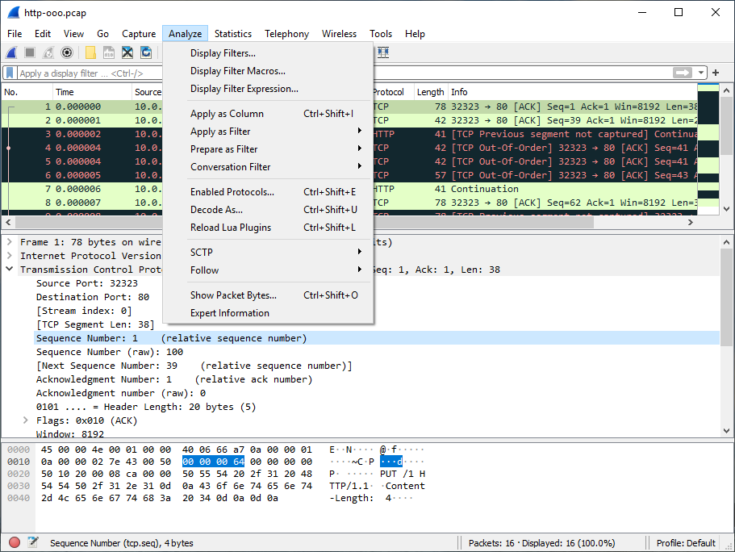

The “Statistics” Menu in wireshark

The Wireshark Statistics menu contains the fields 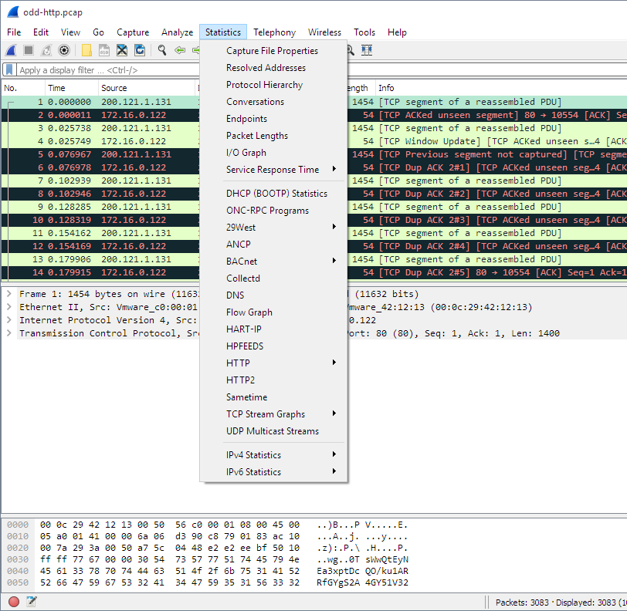shown in Table 3.9, “Statistics menu items”.

Filters in wireshark
Wireshark has two filtering languages: capture filters and display filters. Capture filters are used for filtering when capturing packets, “Filtering while capturing”. Display filters are used for filtering which packets are displayed.

